

*Semester Two, 2020*

Question Booklet

**YEAR 9.01/9.05 EXAM**

Student Name: ________________________________

Class: _________

***Time allowed for this paper***

Recommended Reading time: Ten minutes

Working time for paper: Eighty minutes

***Materials required/recommended for this paper***

This Question/Answer Booklet

Multiple-choice Answer Sheet

Periodic Table

**Students to provide:**

Standard items: pens, pencils, eraser, ruler, highlighters

Special items: non-programmable calculators satisfying the conditions set by the School

No other items may be taken into the examination room. It is your responsibility to ensure that you do not have any unauthorized notes or reference material. If you have any unauthorized material with you, hand it to the supervisor before reading any further.

***Structure of this paper***

This paper requires students to answer **29** questions. The highest possible mark is 68. The candidate’s examination percentage will be calculated on the basis of the fraction of 68 examination marks scored by the candidate.

|  |  |  |  |  |
| --- | --- | --- | --- | --- |
| **SECTION** | **No. of questions available** | **Suggested working time**  **(minutes)** | **Marks available** | **Your marks** |
| Section 1:  **MULTIPLE CHOICE** | 20 | 25 minutes | 20 |  |
| Section 2:  **SHORT ANSWER** | 14 | 45 minutes | 42 |  |
| Section 3:  **EXTENDED RESPONSE** | 1 | 10 minutes | 6 |  |

***Instructions to candidates***

Answer the questions according to the following instructions.

Section One: Answer all questions on the separate Multiple-choice Answer Sheet provided. For each question cross the box to indicate your answer. Use only a blue or black pen to shade the boxes.

Section Two:  Write your answers in the space provided in this Question/Answer Booklet. Wherever possible, confine your answers to the line spaces provided. Use a blue or black pen (**not** pencil) for this section.

Section Three: Write answer in the space provided.

**DO NOT WRITE ON OR MARK THIS PAPER**

**SECTION ONE - MULTIPLE CHOICE** [20 marks]

This section has **20** questions. Answer **all** questions on the separate Answer Booklet provided. ________________________________________________________________________

1. Which of the following statements about atoms is true?
2. Neutrons and protons are found in the nucleus with the electrons
3. The number of neutrons found in the nucleus of an atom is always the same
4. Protons circle the nucleus all the time
5. An atom is mostly empty space
6. The nucleus of an atom is made up of
7. electrons and protons
8. protons and neutrons
9. neutrons and electrons
10. neutrons
11. An ion is best defined as: An atom which has
12. lost electrons
13. gained electrons
14. gained or lost electrons
15. gained neutrons
16. The atomic symbol for a gold atom is . Clarify what this tells you about the gold atom.
17. It contains 118 protons.
18. It contains a total of 197 protons, neutrons and electrons.
19. It contains 118 neutrons.
20. It contains 197 electrons.
21. What is the electronic configuration of a chlorine atom? Hint: Chlorine has an atomic number of 17?
22. 2,2,2,2,2,2,2,2,1
23. 2,8,7
24. 8, 8, 1
25. 2,10,5
26. A phosphorus atom has an atomic number of 15. State how many electrons it has in its third (outermost) shell.
27. 0
28. 2
29. 5
30. 8

7. A radionuclide is:

1. a radioactive isotope.
2. a charged atom
3. an element that emits beta radiation.
4. an atom with the same number of protons but a different number of neutrons.
5. The mass number of an atom is the number of
6. neutrons in its nucleus.
7. electrons in the nucleus.
8. protons in the nucleus.
9. protons plus neutrons in the nucleus.
10. Which of the following will cause an atom to become a negative ion?
11. Gains electrons.
12. Loses protons.
13. Gains neutrons.
14. Loses neutrons.
15. Scientists use the process of decay in radioactive isotopes called to determine the of organisms.

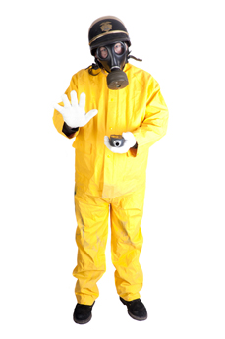

1. aging; carbon
2. radioactive aging; carbon
3. dating; age
4. carbon dating; age

1. State the general name for organisms that cause disease.
2. Bacterium
3. Antibody
4. Pathogen
5. Virus
6. Identify the chemicals or drugs that kill bacteria
7. Biotics
8. Antibiotics
9. 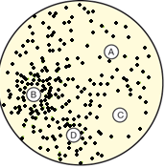Aspirin
10. Antifungicides
11. Four paper discs were soaked in antibiotics. The discs were placed

on a plate with a large number of colonies of bacteria. The aim of the

experiment was to test the effectiveness of the antibiotics. After three days

the plate was examined. The results are shown above.

Identify the antibiotic that was most effective in killing the bacteria.

The one in disk

1. A
2. B
3. C
4. D
5. Which of these will be in the first line of defence?
6. Skin
7. b. Fever
8. T-cells and B cells
9. White blood cells
10. The products of the body’s endocrine system are
11. ions.
12. hormones.
13. enzymes.
14. minerals.
15. Which observation led to the hypothesis of seafloor spreading?

a. The claim of a large land mass referred to as Pangaea.

b. That there is a Global Rift system and undersea mountains.

c. Scientists in 1872 discovering a mountain ridge in the Atlantic Ocean.

d. The earth has several layers with different physical properties.

1. What is the most correct definition for a secondary wave? A
2. Longitudinal wave is the faster than a primary wave and can travel through solid, liquids and gases.
3. Longitudinal wave is the slower than a primary wave and can travel through solid, liquids and gases
4. Transverse wave is faster than a primary wave and can travel through solid, liquids and gases
5. Transverse wave is slower than a primary wave and can travel through solid, liquids and gases
6. An island chain such as the Hawaiian Islands, provided evidence for which tectonic process?
7. Plate movement
8. Subduction
9. Collision boundaries
10. Rifting
11. When was the supercontinent, Pangea, formed on the surface of the Earth?
12. 50 - 75 million years ago
13. 5-10 million years ago
14. 100- 150 million years ago
15. 200- 250 million years ago
16. Which of the following is the correct order of the layers of the Earth, from the centre to the surface?
17. Crust, Mantle, Outer Core, Inner Core
18. Inner Core, Outer Core, Mantle, Crust
19. Outer Core, Inner Core, Mantle, Crust
20. Mantle, Inner Core, Crust, Outer Core

**Year 9 Science 9.01/9.05**

**Semester 2 Exam 2020**

**MULTIPLE CHOICE ANSWER BOOKLET**

**NAME:**

**FORM: DATE:**

|  |  |
| --- | --- |
| **I CAN STATEMENTS** | **QUESTIONS** |
| **MUST**  Explains global features and events in terms of geological processes and timescales.  Describes natural radioactivity as a substance giving out energy and particles in order to become more stable.  Analyses how biological systems function and respond to external changes, describing them in general terms. | 1, 2, 3, 7, 8, 10, 11, 12, 14, 15, 16, 17, 18, 19, 20, 21, 22, 23, 24, 25, 26, 27, 28, 29, 30 |
| **SHOULD**  Explains in detail global features and events in terms of geological processes and timescales.  Explains natural radioactivity as atomic nuclei giving out energy and particles in order to become more stable. Describes the general properties of radioactive emissions.  Analyses how biological systems function and respond to external changes and compares the functions of different biological systems. | 4, 5, 6, 7, 9, 13, 21, 23, 25, 26, 30 |
| **COULD**  Explains in detail how global features and events result from geological processes which change Earth’s surface over geological timescales.  Explains natural radioactivity as unstable atomic nuclei giving out alpha and beta particles or gamma radiation in order to become more stable. Describes the properties of alpha, beta and gamma radiation.  Analyses in detail how biological systems function and respond to external changes, and describes how different biological systems coordinate. | 21, 23, 28, 29, 30 |

**Total**

**/68**

**Section 3**

**/6**

**Section 2**

**/42**

**Section 1**

**/20**

**SECTION TWO - SHORT ANSWER SECTION**  **[42** marks]

____________________________________________________________________________

**Question 21**

1. For the electron configuration of the atom given below, construct an electron diagram and write the name of the element you have drawn. Use this atom to answer all parts of this question. (2 marks)

Electron Configuration: **2, 8, 1**

Element: _________________________

1. Identify

(i) Number of electrons in the valence shell: ______________ and

(ii) Type of ion formed: ________________ (2 marks)

1. Draw the complete electron shell diagram for the ion that is formed by this atom. (3 marks)
2. State the electron configuration of the ion. _____________________ ( 1 marks)
3. Demonstrate how the charge on the ion is calculated ie, provide the sum. (2 marks)

**Question 22**

Carbon has different isotopes, as shown in the diagram below.

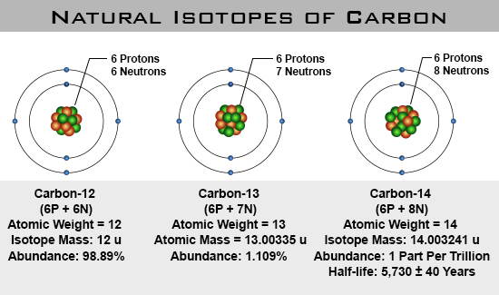

Describe the similarities and differences between these shown. (3 marks)

**Question 23**

The atoms below are written using the letters V to Z instead of their correct chemical symbols.

     (4 marks)

1. Which two atoms have the same number of neutrons?

______________________________________________________________________________

1. Which atom has the smallest mass number?

______________________________________________________________________________

c) Which two atoms belong to the same element?

______________________________________________________________________________

1. Which atom has the electron configuration 2, 8?

_____________________________________________________________________________

**Question 24**

This paragraph has some missing words. Place the correct answers in the spaces below. (6 marks)

**charge electrons negatively nucleus protons Rutherford**

Ernest _______ proposed a new model for the atom where there is a small positively-charged _______ surrounded by _______ -charged electrons. Later on scientists discovered that there were two types of particles inside the nucleus—positively-charged _______ and neutrons, with no _______ . The number of protons is always the same as the number of _______ .

**Question 25**

1. Explain the three lines of defence that the body has to prevent infection. (3 marks)

|  |  |  |
| --- | --- | --- |
| **Line of Defence** | **One Example** | **How does it prevent infection?** |
| 1st |  |  |
| 2nd |  |  |
| 3rd |  |  |

**Question 26**

Compare and contrast viruses and bacteria.

In the Venn diagram include the following information.

* 1. State two similarities. (2 marks)
  2. State two differences. (2 marks)
  3. Name at least one treatment or preventative measure you can use for a bacterial and viral infection. (2 marks)

**Question 27 Label 8 of the plates on the map below** (4 marks)

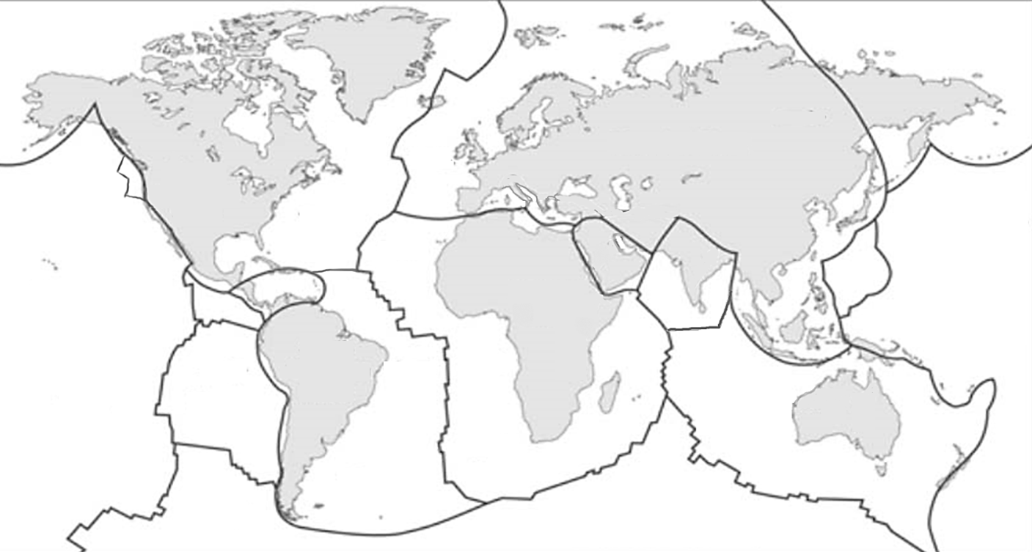

**Question 28**

**Fill in the table below about the types of boundaries.** (6 marks)

|  |  |  |  |
| --- | --- | --- | --- |
| Type of boundary | Diagram showing arrows of plate movement | Landscape that forms at this boundary | Does an earthquake or volcano occur here? |
|  |  |  |  |
|  |  |  |  |
|  |  |  |  |

**SECTION THREE: EXTENDED RESPONSE** (6 marks)

29) Some isotopes of the elements are unstable. This means they may undergo decay or change into another isotope and emit certain radiations.

1. List three types of radiation in order from least penetrating to most penetrating.
2. Compare the (similarities and differences) properties of those radiations. You need to show at least two properties for each radiations.
3. What do you mean by the term half-life of a radioactive material?

_______________________________________________________________________________

**END OF EXAM**

Please check your work!

REMEMBER – BLANK SPACES GET NO MARKS, HAVE A GO – YOU CANNOT LOSE MARKS.